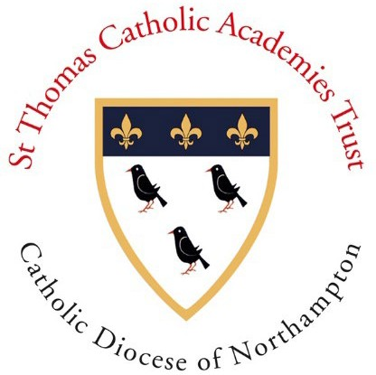St Thomas Catholic Academies Trust

Our Lady’s Catholic Primary School – Academy Committee 2024-2025

**Structure:** This committee is an Academy Committee of the St Thomas Catholic Academies Trust. There are no sub-committees. The Committee meets at least once each long term.

|  |  |  |  |  |  |  |  |
| --- | --- | --- | --- | --- | --- | --- | --- |
| **Name** | **Date of appointment** | **Date Left** | **Roles** | **Appointed by** | **Attendance 2023/24** | **Interests declared** | **Other Governor Positions Held** |
| **Maria Fotheringham** | 01 09 2020 |  |  | Bishop of Northampton | 5/5 | None declared |  |
| **Mark Holdsworth** |  |  | Head Teacher | Ex-officio | 5/5 | None declared |  |
| **Sarah Lally** | 16 03 2022 |  |  | Staff | 5/5 | None declared |  |
| **Mark Haines** | 01 02 2024 |  |  | Bishop of Northampton | 3/3 | None declared |  |
| **Previous Governors** |  |  |  |  |  |  |  |
| Amanda Healy | 09 12 2019 | 31 08 2024 | Chair of  Governors | Bishop of Northampton | 5/5 | None declared |  |
| David Curtis | 01 02 2022 | 15 04 2024 |  | Bishop of Northampton | 3/3 | None declared |  |

The Chair of the

Academy Committee can be contacted via the Clerk: [jcope@stcat.co.uk](mailto:jcope@stcat.co.uk)